Logic Model SAMPLE
Priority Area: Alcohol Use
Outcomes

(Strategic Prevention Plan Objective 1.2)
By 2022, reduce retail availability of alcohol to teens by 1% as measured by Alcohol Beverage Control infractions.
- Decrease number of violations related to selling to alcohol to minors.
- Increase number of alcohol vendors in compliance.

(Strategic Prevention Plan Objective 1.1)
Increase perception of harm of alcohol use among teens by 3% according to the Community Needs Assessment in year 2025 compared to year 2022.
- Increase knowledge pre/post regarding alcohol misuse/abuse
- Increase self-confidence, self-esteem.

Protective Factors
INSTRUCTIONS FOR MANUALLY INSERTING SHAPES AND LINES
NOTE: This method is optional. You may use other software and/or tools to create your logic model.
- On Microsoft Word, go to the Insert tab on the toolbar, and click on Shapes.
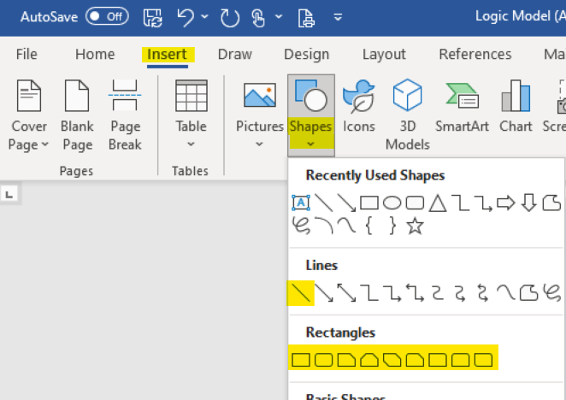
- Select a shape or line of your choice
- Use your cursor to draw, adjust, and move the shape.
- To change the format, select the shape(s), go to the Shape Format tab on the toolbar, and format as needed.
