Improving Physical Activity Opportunities through Joint/Shared Use Agreements between School Districts and Cities
City of Pasadena and Pasadena Unified School District

Why Joint/Shared-Use Agreements
Joint/Shared-use brings together two entities to expand access to an indoor and/or outdoor space for community use. School campuses are often the ideal partner, providing an abundant amount of outdoor space for neighborhood recreational opportunities, especially in densely populated neighborhoods, or neighborhoods without convenient access to green space. By increasing the public’s access to green space, physical activity levels will increase, and the growing epidemic of obesity will decrease. Health disparities across Los Angeles County due to a lack of green space will also decrease.
27 School Campuses for Grades K-12
18,457 Total Students

58.3% Hispanic/Latino
18% African American
4.7% Asian
19% Whites/All Other Races

21.2% 5th Graders Need Improvement in BMI
17.9% 7th Graders Need Improvement in BMI
19.9% 9th Graders need improvement in BMI

Demographics
*Data provided by the Pasadena Unified School District (15/16) and California Department of Education (14/15)

Shared Use in Action
In 2008, the City of Pasadena and PUSD agreed on a Memorandum of Understanding that would allow the use of the playground at Linda Vista School to the community, and have since renewed it. Since then, The City of Pasadena and PUSD have entered into joint use agreements with 7 other PUSD sites. The City of Pasadena has also provided funds to make improvements to shared use sites, including installing and improving play areas and equipment, bathrooms, drinking fountains, lighting, and paved areas.
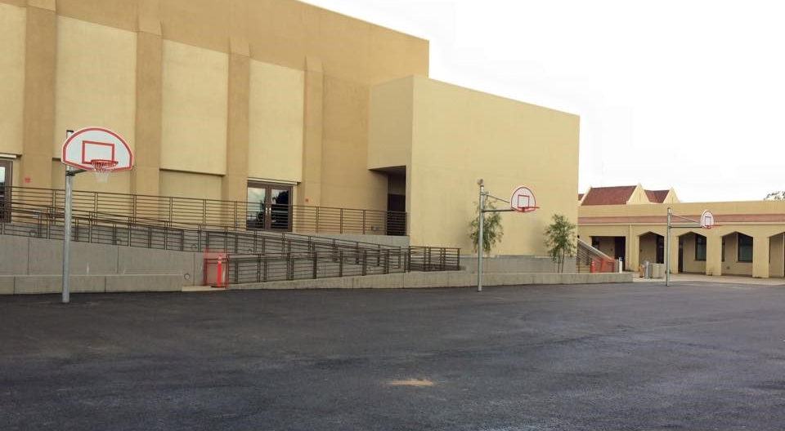
Benefits
Through this partnership, the City of Pasadena and the Pasadena Unified School District have committed to establish and sustain collaborative initiatives to build stronger neighborhoods. Shared use has allowed the City of Pasadena to invest in improving school facilities and structures for public use, which creates a positive and welcoming environment for students, families, and residents of Pasadena

Challenges and Solutions
When entering joint/shared-use agreements, barriers such as liabilities and maintenance costs exist. However, with a properly written agreement, the city and district’s roles and responsibilities are clearly defined.

